**VetPet**

**User's Manual**

**CSCI-P465/565 (Software Engineering I)**

**Project Team**

**Jainendra Kumar  
Amey Avinash Tarfe  
Christian Justice Gonzalez  
Xin Ran Dai**

**1. Product Overview**

VetPet intends to streamline the treatment of animals by veterinary doctors through a centralized web portal which acts as a medium of communication between the two parties. In addition to the two user types i.e. patients and doctors, the system provides additional functionality by connecting pet owners and doctors with insurance providers. This allows them to take tailored insurance plans for their pets as well providing a platform for insurance providers to reach their target consumers.

In addition to the above main functionality, the system provides additional sub functionalities such as hospital locator, chat feature, doctor review or rating system. Security and user privacy is another aspect which has been taken care of in the developed product by providing features such as two-factor authentication, Google authorization, and password encryption.

The system will be unique in a way that very few existing systems currently exists in the country which centrally govern the treatment of animals.

**2. System Requirements**

The minimum system requirements for the application to run are very basic:

* A stable internet connection
* A web browser: Google chrome version: 62.0.3202, Mozilla Firefox version: 57.0.1 or Opera version: 2018, Microsoft Edge (or better).
* The website does not require any special extensions or plugins.

**3. Product Installation**

The website uses J2EE framework (JSP), HTML, CSS, JavaScript, Apache Tomcat Server, and MySQL database. Below are the steps to install and deploy the essential tools needed to run the application:

**JAVA**

[**https://java.com/en/download/manual.jsp**](https://java.com/en/download/manual.jsp)

**Taken from Oracle website :**

[**https://java.com/en/download/help/windows_manual_download.xml#download**](https://java.com/en/download/help/windows_manual_download.xml#download)

**“**It is recommended, before you proceed with online installation you may want to disable your Internet firewall. In some cases the default firewall settings are set to reject all automatic or online installations such as the Java online installation. If the firewall is not configured appropriately it may stall the download/install operation of Java under certain conditions. Refer to your specific Internet firewall manual for instructions on how to disable your Internet Firewall.

* Go to the [Manual download](https://java.com/en/download/manual.jsp) page
* Click on **Windows Online**
* The File Download dialog box appears prompting you to run or save the download file   
  + To run the installer, click **Run**.
  + To save the file for later installation, click **Save**.   
    Choose the folder location and save the file to your local system.   
    Tip: Save the file to a known location on your computer, for example, to your desktop.  
    Double-click on the saved file to start the installation process.
* The installation process starts. Click the **Install**button to accept the license terms and to continue with the installation.” [2]

**Apache Tomcat**

[**https://tomcat.apache.org/download-80.cgi**](https://tomcat.apache.org/download-80.cgi)

**Taken from Apache tomcat website**

**(**[**https://tomcat.apache.org/tomcat-7.0-doc/setup.html**](https://tomcat.apache.org/tomcat-7.0-doc/setup.html)**)**

“Installing Tomcat on Windows can be done easily using the Windows installer. Its interface and functionality is similar to other wizard based installers, with only a few items of interest.

* **Installation as a service**: Tomcat will be installed as a Windows service no matter what setting is selected. Using the checkbox on the component page sets the service as "auto" startup, so that Tomcat is automatically started when Windows starts. For optimal security, the service should be run as a separate user, with reduced permissions (see the Windows Services administration tool and its documentation).
* **Java location**: The installer will provide a default JRE to use to run the service. The installer uses the registry to determine the base path of a Java 6 or later JRE, including the JRE installed as part of the full JDK. When running on a 64-bit operating system, the installer will first look for a 64-bit JRE and only look for a 32-bit JRE if a 64-bit JRE is not found. It is not mandatory to use the default JRE detected by the installer. Any installed Java 6 or later JRE (32-bit or 64-bit) may be used.
* **Tray icon**: When Tomcat is run as a service, there will not be any tray icon present when Tomcat is running. Note that when choosing to run Tomcat at the end of installation, the tray icon will be used even if Tomcat was installed as a service.
* **Defaults**: The defaults used by the installer may be overridden by use of the /C=<config file> command line argument. The configuration file uses the format name=value with each pair on a separate line.” [1]

Configure apache tomcat server.xml and context.xml according to your local MySQL database connection string and paths.

**MySQL**

#### Installation Using MySQL Installer (taken from MySQL website)

“The general MySQL Installer download is available at <https://dev.mysql.com/downloads/windows/installer/>.

The MySQL Installer application can install, upgrade, and manage most MySQL products, including MySQL Workbench. This is the recommended approach.”

**GitHub Application Link:**

[**https://github.iu.edu/xinrdai/P565-HealthInsuranceSystem**](https://github.iu.edu/xinrdai/P565-HealthInsuranceSystem)

Clone the github repo from the master branch and integrate it with your IDE and Apache Tomcat.

Once all the above steps are completed, run the apache tomcat application server via an IDE or manually. Open the web browser with the following URL which should load your website:

<http://localhost:8080/HMS/JSP/visitorHome.html>

**4. Product Operation**

The website navigation has been made very consistent and user friendly so as to avoid confusion and ambiguity.

**Homepage:**

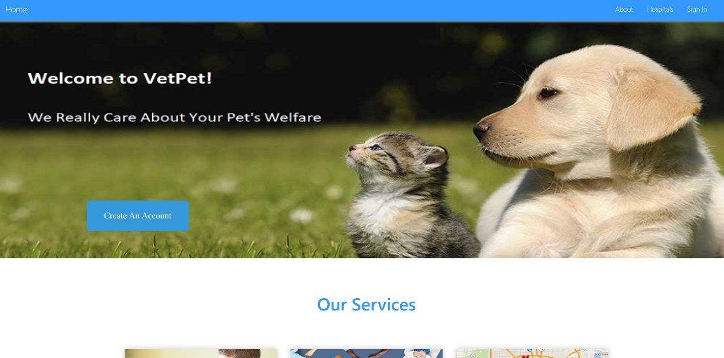

**Figure 1**

Figure 1 shows the homepage of the website i.e. the first page that greets the visitor.

**Login:**

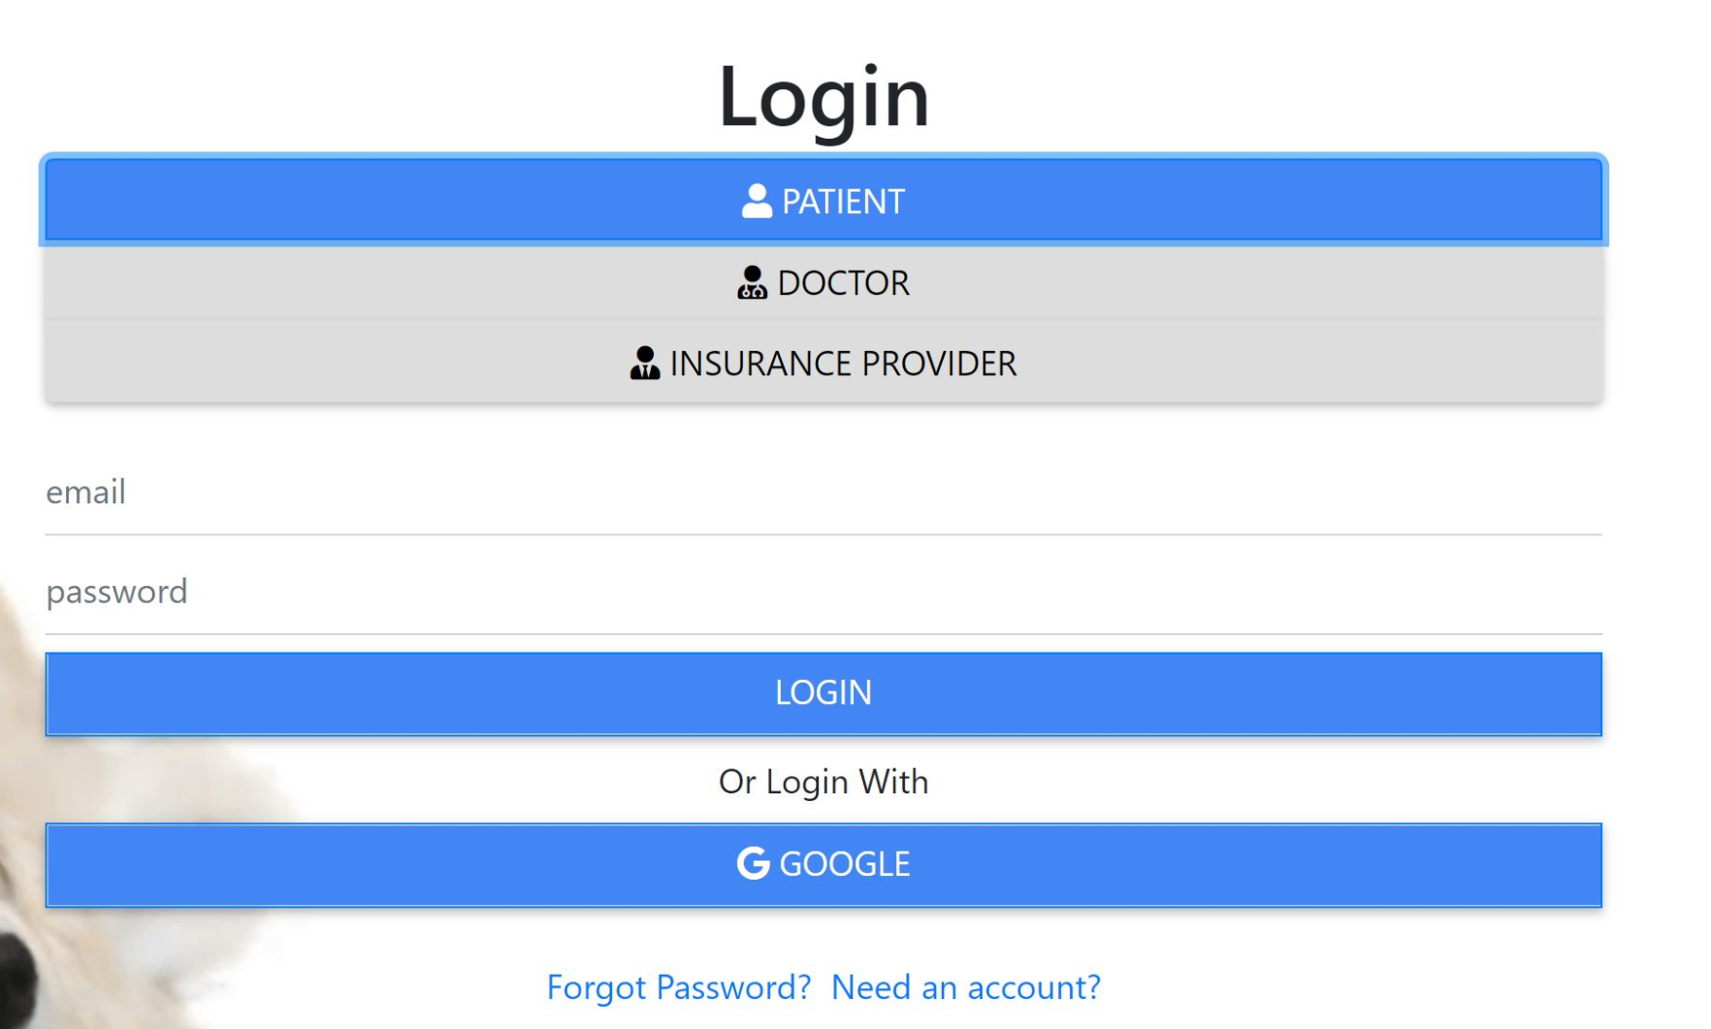

Figure 2

Figure 2 shows the sign in page where the users can sign in depending upon their user type. A user friendly selector is provided for them to select their account type.

**Registration:**

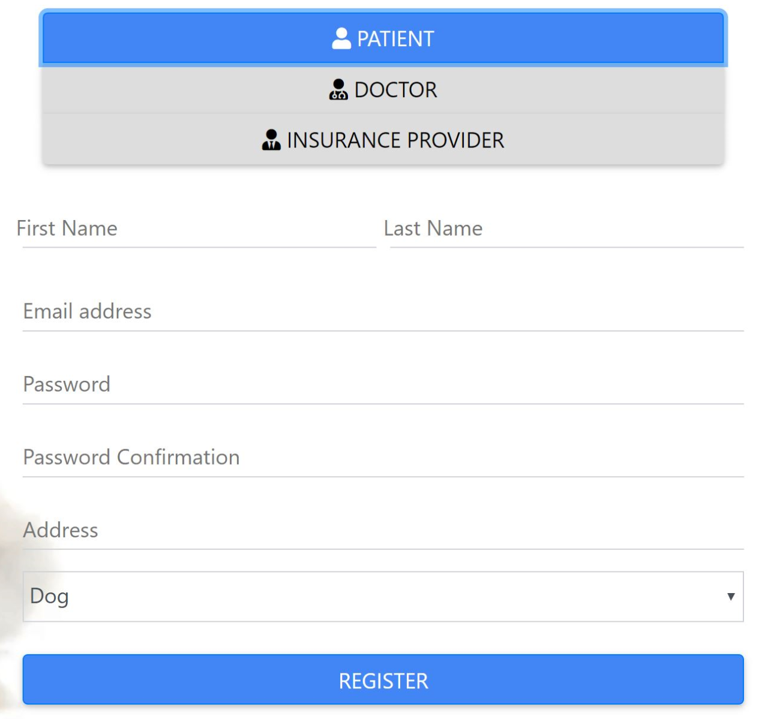

Figure 3

Figure 3 shows the registration page where the user can fill their personal details to access functionalities provided by the website.

**Google OAuth:**

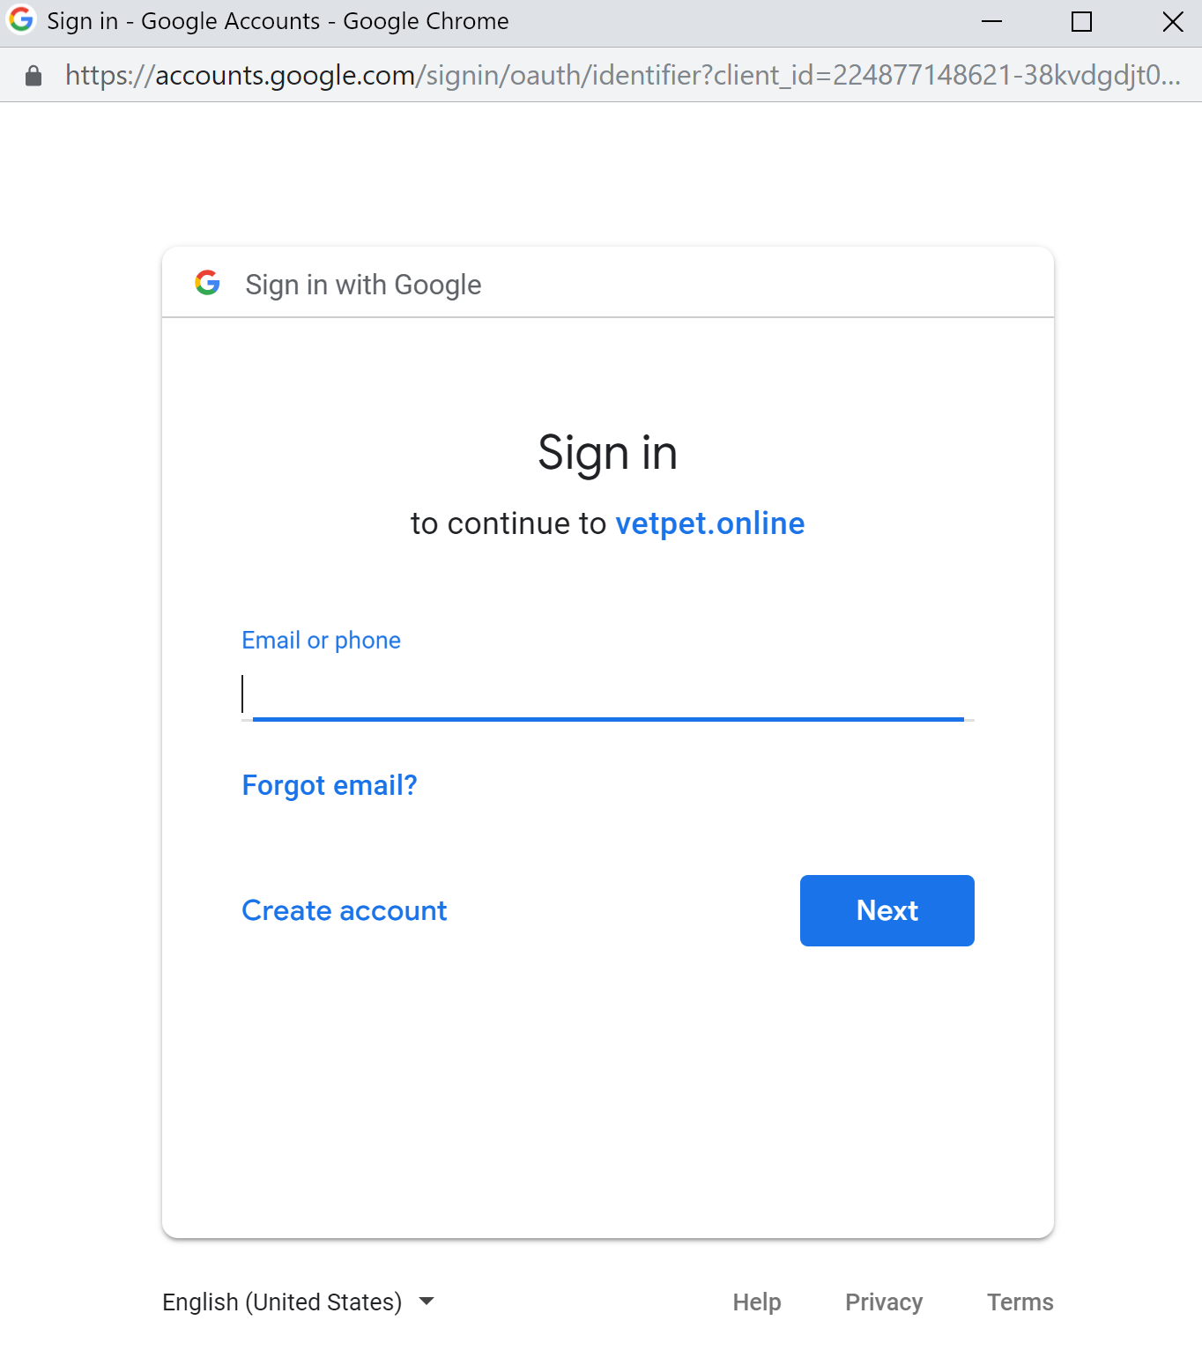

Figure 3

Figure 3 shows Google OAuth whereby users can sign in with their Gmail credentials.

**Two factor email authentication:**

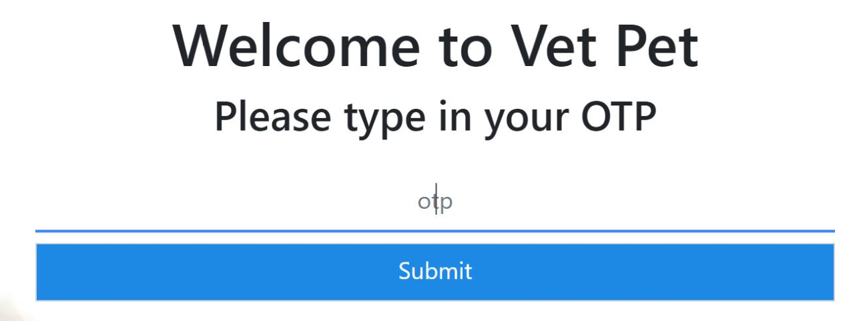

Figure 4

**Patient’s view**

After entering the OTP, the user is redirected to the homepage of the website, where the user can reap the benefits of the services provided by the website for the patients as show in figure 5.

**Homepage**

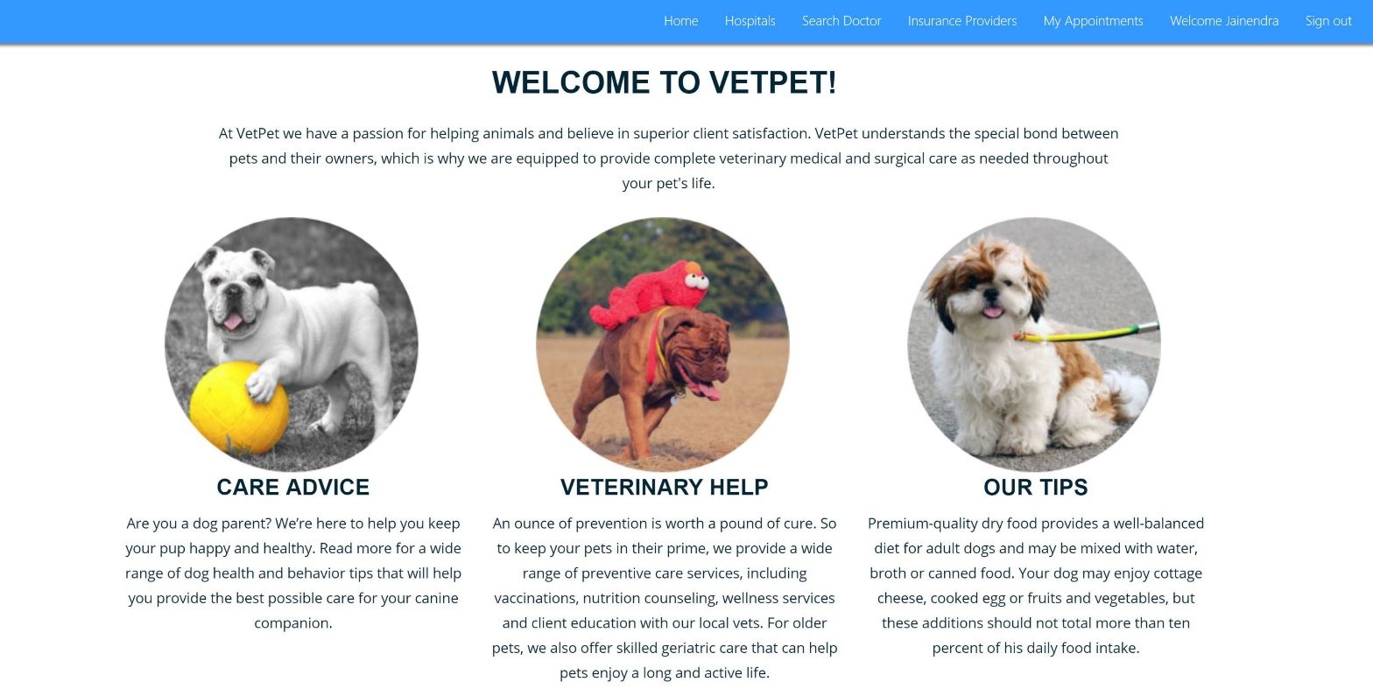

Figure 5

Now, by clicking on the ‘Search Doctor’ on the navbar as shown in the figure 6, the patient is redirected to the Search doctor page where, the user can search for the doctors according to the pet-type and the specialization of the doctor (Figure 7).



Figure 6

**Search Doctor**

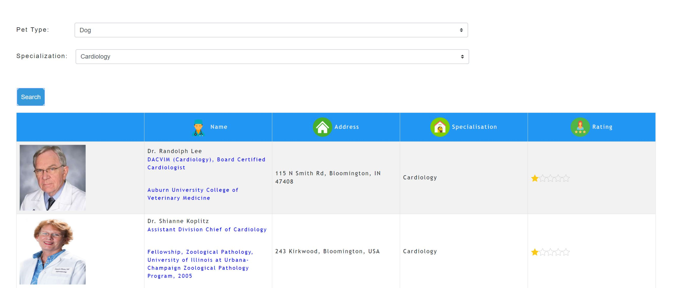

Figure 7

Figure 7 shows that the patient can search the doctor as per the specialization he is looking for.

**Book Appointment**

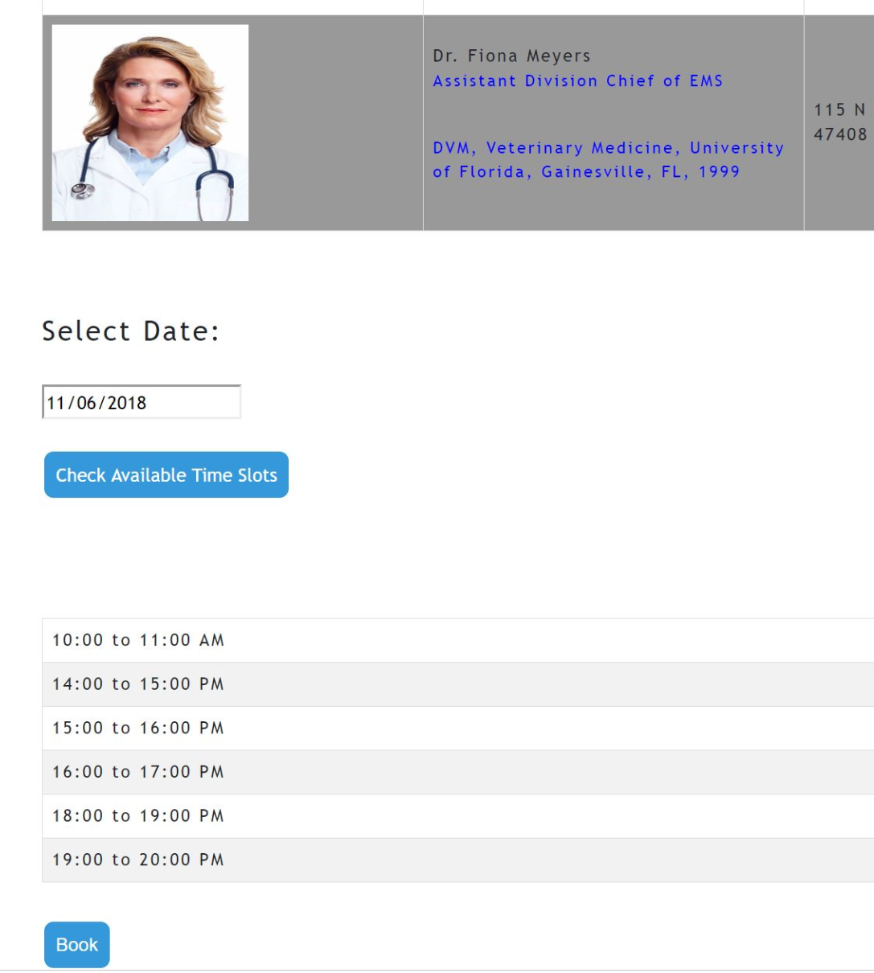

Figure 8

Patient can book the appointment with the doctor as per the available timeslots on a particular date as shown in the Figure 8.

**Give Rating**

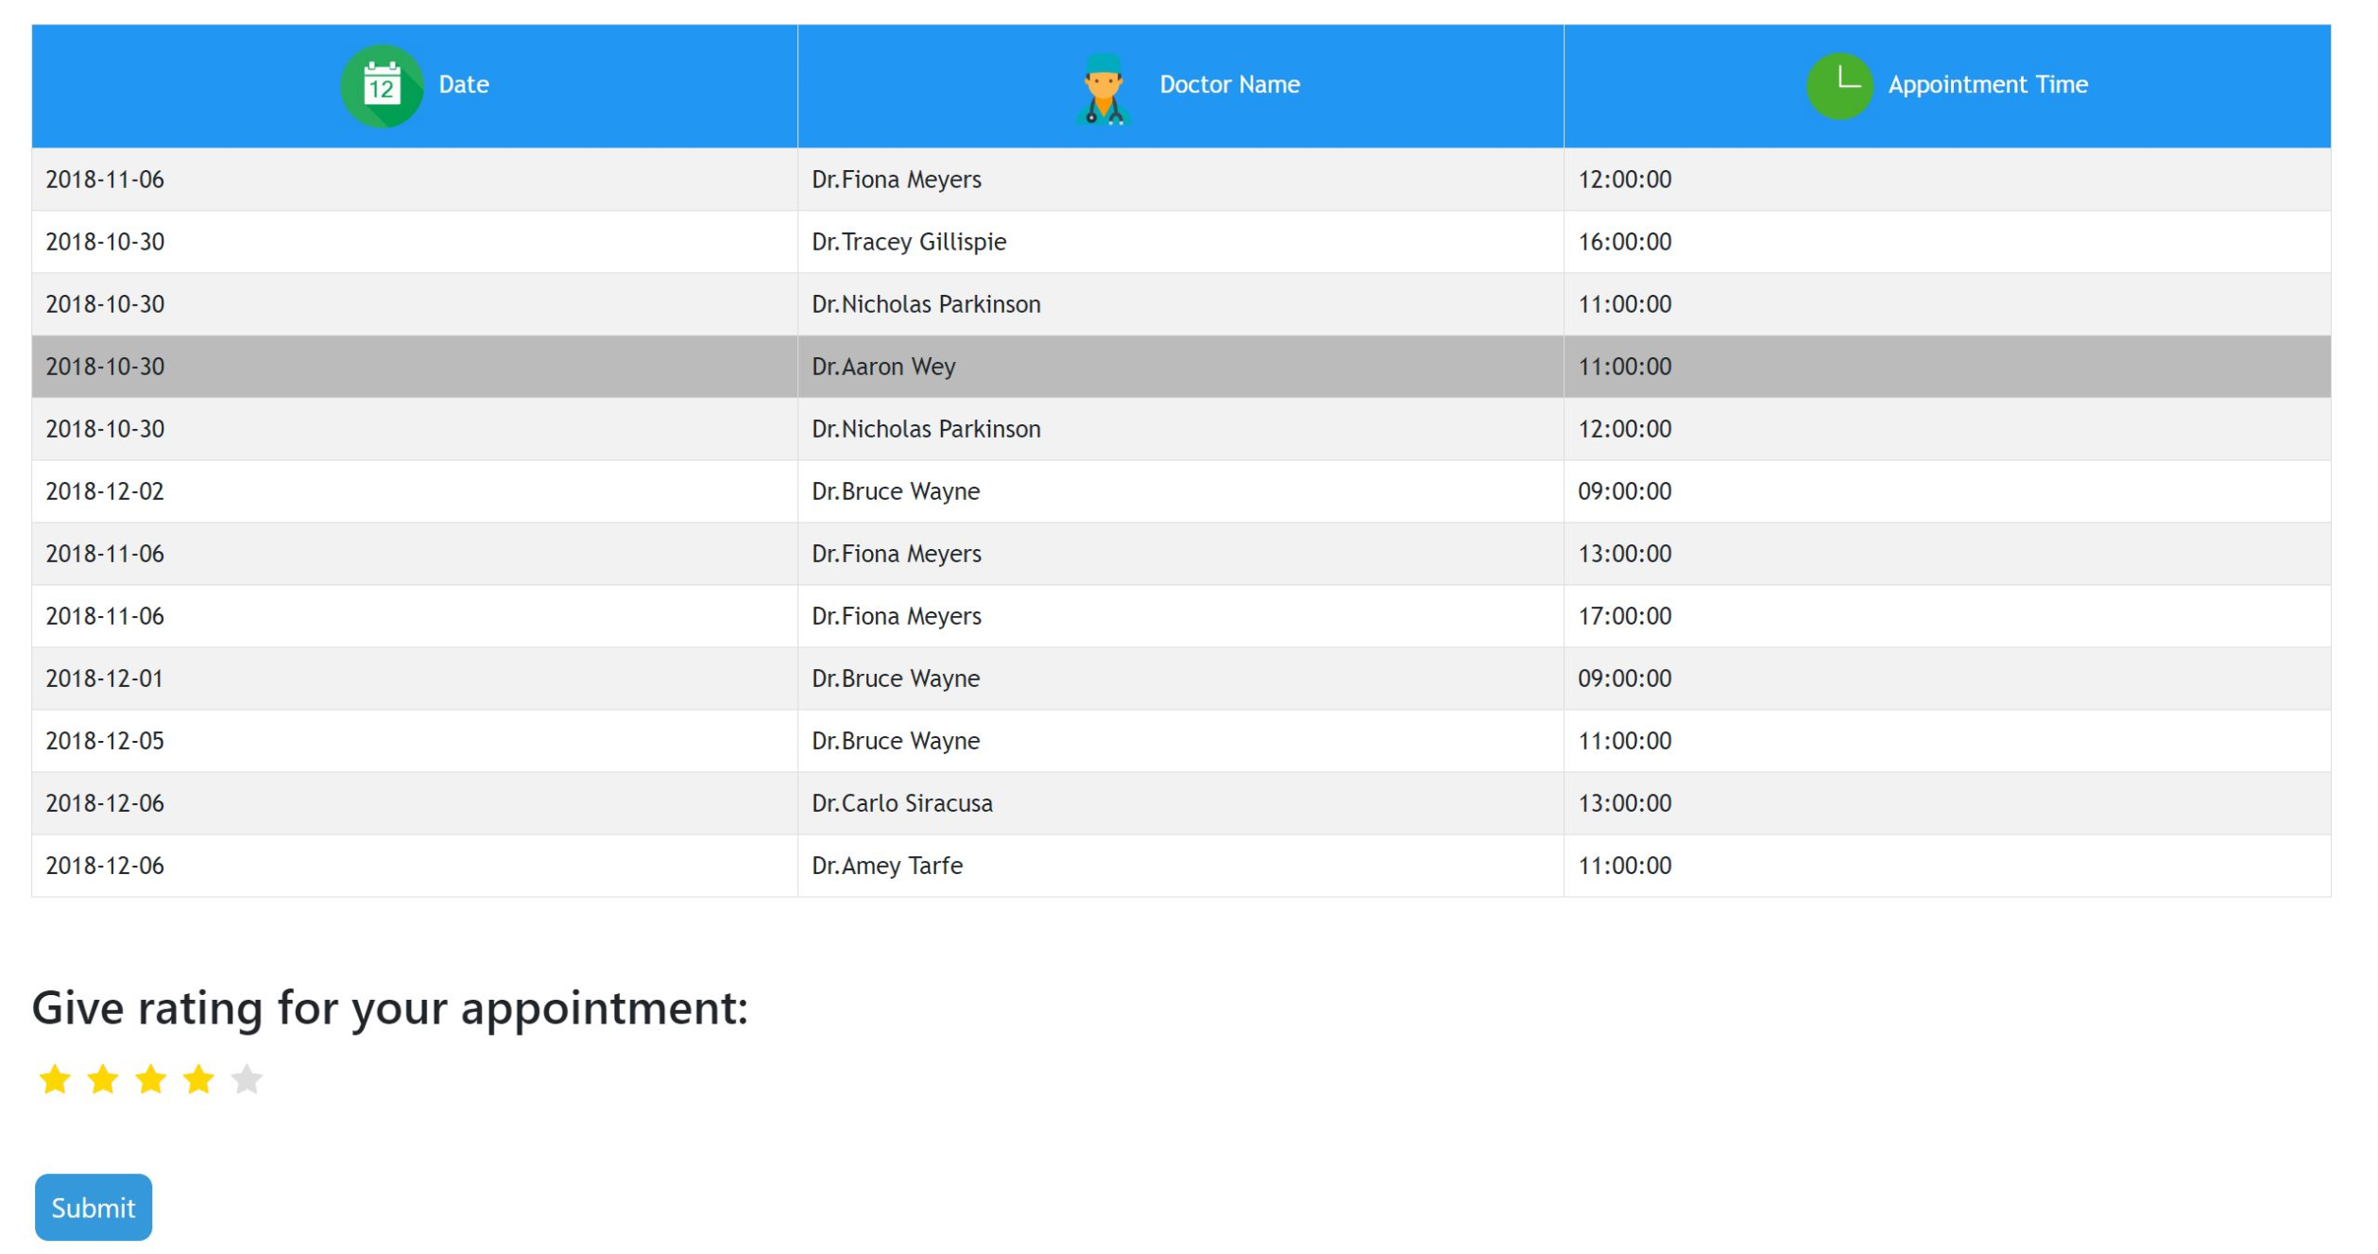

Figure 9

The patient can give rating to the doctor based on his appointment as shown in Figure 9

**Search Insurance Plans**

The patient can also buy the insurance for his pet which will help to cover all or most of the healthcare costs associated with the pet’s treatment.

The insurance plan is classified according to the deductible the plan is offering, the premium and the pet type i.e. whether the pet is a cat or a dog. Figure 10 shows the insurance plan search form.

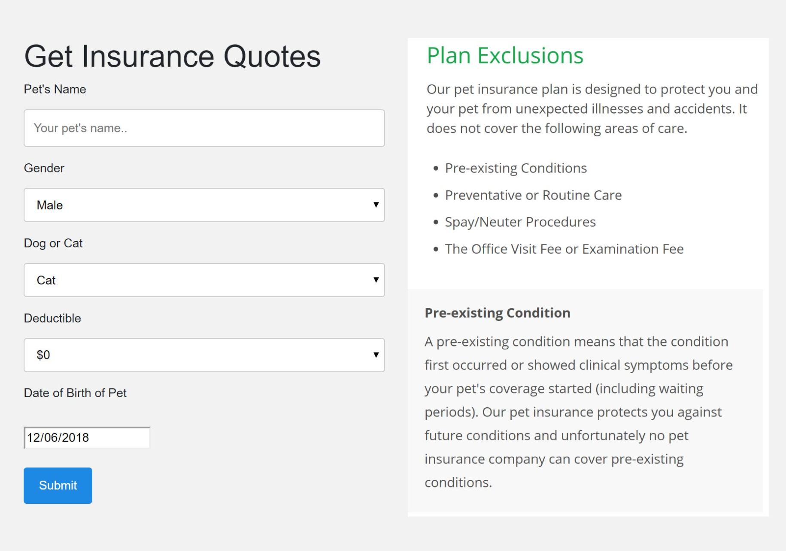

Figure 10

**Select Insurance Plans**

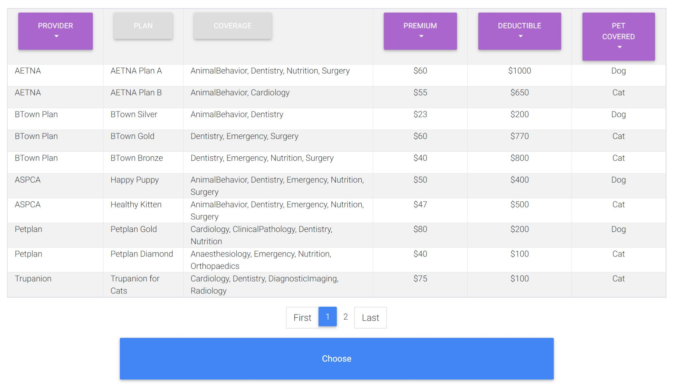

Figure 11

Figure 11 shows a filterable table where the user can select the insurance table by searching and filtering out plans he does not require.

**Payment**

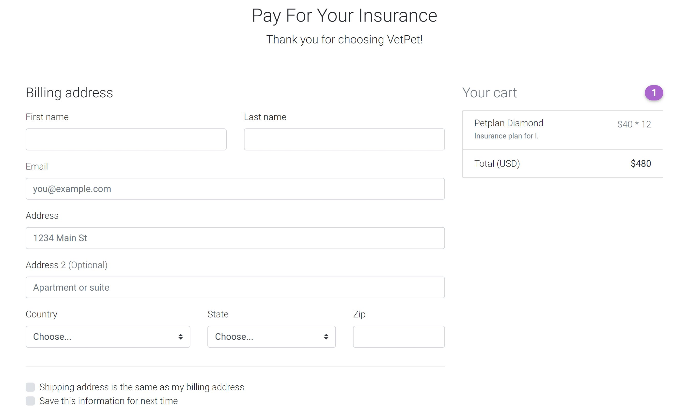

Figure 12

On successful selection, the user is directed to a payment gateway page where he can fill out his payment details to purchase the plan as shown in Figure 12.

**Hospital Locator**

The user can view the locations of the hospitals associated with our websites using a google map feature which is integrated in our website.

The hospitals and their locations are represented by red markers on the map as shown in Figure 13.

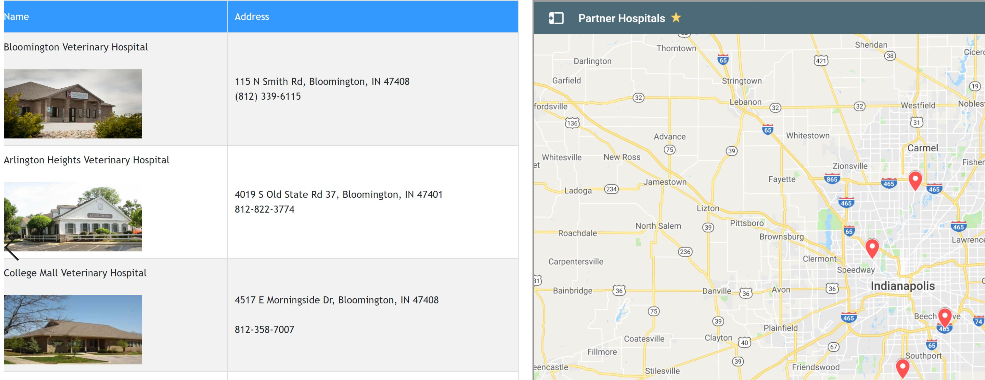

Figure 13

**Doctor’s View:**

**Login:**

The doctor can login to the system using his/her credentials similar to the patient’s login but select the account-type as doctor (shown in Fig. 14).

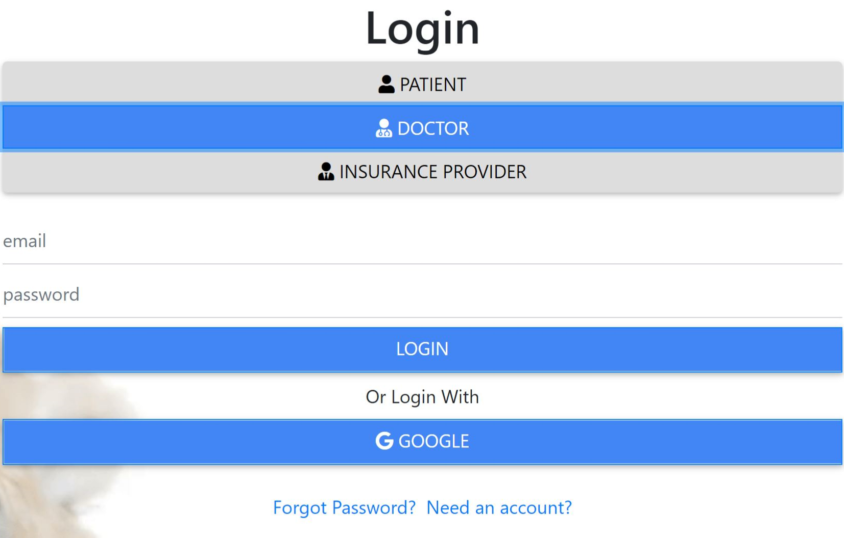

Figure 14

Rest of the functions such as registration and dual authentication is same as that of the account-type: Patient.

**Set available dates for appointments:**

In the doctor’s view of the system, the doctor can set the dates for the appointments. The doctors have to first click on Set date and then, just select an available date and time from the menu as shown in Fig. 15

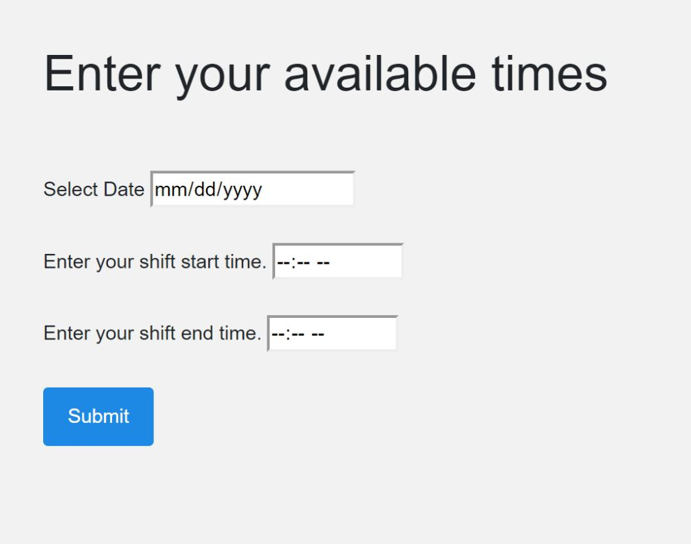

Figure 15

**See the scheduled appointments:**

The doctor can view all the appointments for the patients in his view by clicking on ‘My appointments’ tab provided on the navbar (Fig. 16).

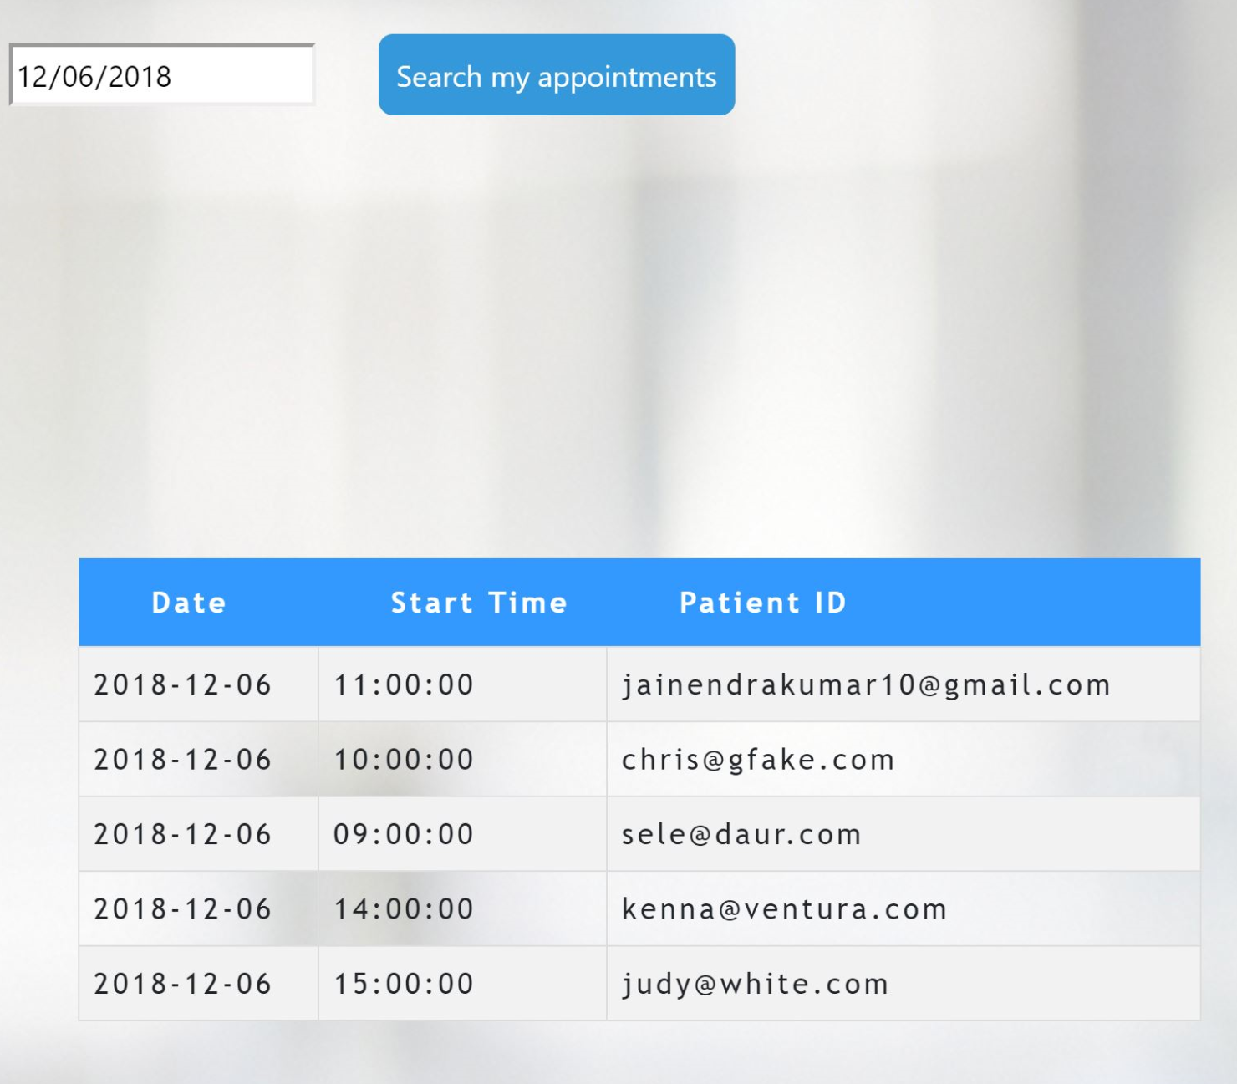

Figure 16

**Sign out and Security:**

The sign out function is exactly the as the patient’s view. Also, once signed out the session is cleared and the user is not able to go back to the previous page. If an attempt is made then he is redirected to the login page with a pop-up.

**Insurance provider’s view:**

**Login:**

The insurance provider can login to the system using his/her credentials similar to the patient’s login but select the account-type as ‘Insurance provider’.

Rest of the functions such as registration and dual authentication is same as that of the account-type: Patient.

**My Doctors:**

After logging in, the insurance provider can view the list of particular doctors under the provider by clicking on the ‘My Doctors’ tab on the navbar as shown in Fig. 17

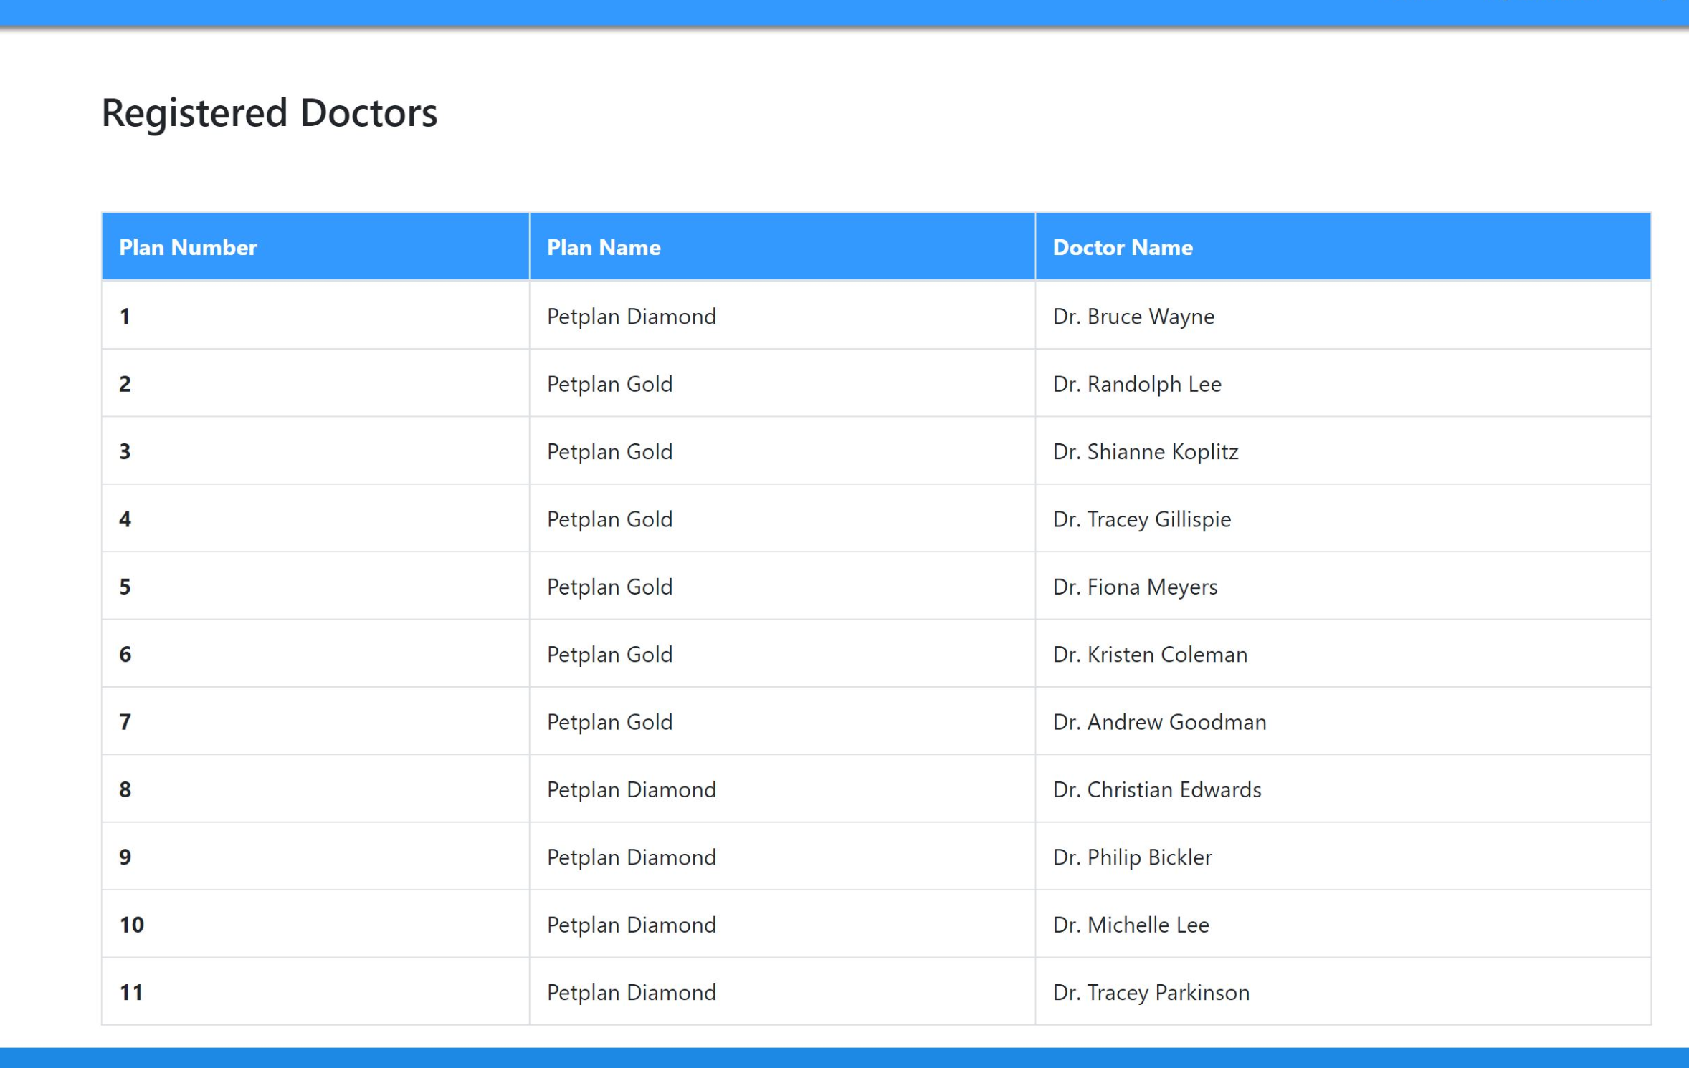

Figure 17

**My Patients:**

The insurance providers also, can see the list of patients subscribing to the various plans under the provider. Just click on ‘My Patients’ tab from the menu, and list of patients will be generated as shown in the figure below.

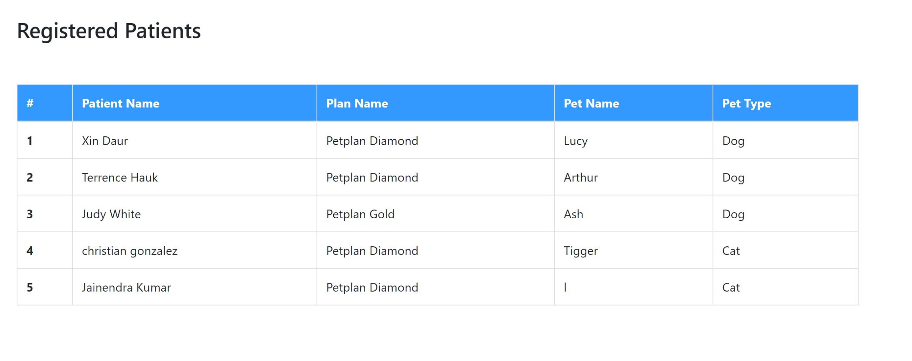

Figure 18

**5. Known Defects**

* Once the user signs out his session is cleared and if tries to access a page by hitting its URL then he is directed back to the login form. However, this is currently limited to only the webpages which are JSPs. If a user hits a HTML page, he maybe able to access the static content of the website but not any dynamic information from the webpage.
* The doctor can only schedule his time in complete hours and not in half hour interval. If he enters a half hour interval for scheduling his shift then an error is generated in the database.
* The server sometimes stalls due to either unknown sockets opened or connections not closed properly.
* There are few UI defects too which also need to be rectified.

**Page Author/Creator:** **Amey Tarfe and Jainendra Kumar**